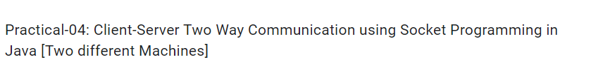

CLIENT.java FILE

import java.io.*\**;

import java.net.*\**;

public class client {

    public static void main(String[] args) {

        try {

            Socket s = new Socket("192.168.0.103", 8080);

            BufferedReader br = new BufferedReader(new InputStreamReader(System.in));

            DataOutputStream dout = new DataOutputStream(s.getOutputStream());

            DataInputStream dis = new DataInputStream(s.getInputStream());

            String str = "", str1 = "";

            while (!str.equalsIgnoreCase("bye")) {

                str = br.readLine();

                dout.writeUTF(str);

                dout.flush();

                str1 = dis.readUTF();

                System.out.println("Server = " + str1);

            }

            dout.close();

            s.close();

        } catch (Exception e) {

            System.out.println(e);

        }

    }

}

SERVER.java FILE

import java.io.*\**;

import java.net.*\**;

public class server

{

    public static void main(String[] args)

    {

        try

        {

            ServerSocket ss = new ServerSocket(8080);

            Socket s = ss.accept();

            BufferedReader br = new BufferedReader(new InputStreamReader(System.in));

            DataInputStream dis = new DataInputStream(s.getInputStream());

            DataOutputStream dout = new DataOutputStream(s.getOutputStream());

            String str="",str1="";

            while(!str.equalsIgnoreCase("bye"))

            {

                str = dis.readUTF();

                System.out.println("Client = "+str);

                str1 = br.readLine();

                dout.writeUTF(str1);

                dout.flush();

            }

            dout.close();

            ss.close();

        }

        catch(Exception e)

        {

            System.out.println(e);

        }

    }

}

OUTPUT:

